Chapter 3, Problem 64.

Find v_{o}, and i_{o} in the circuit of Fig. 3.108.

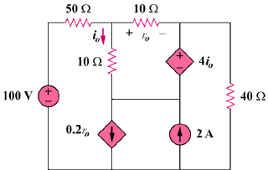
250 V
5 A

Figure 3.108
For Prob. 3.64.

